ANNUAL REPORT 2015-16

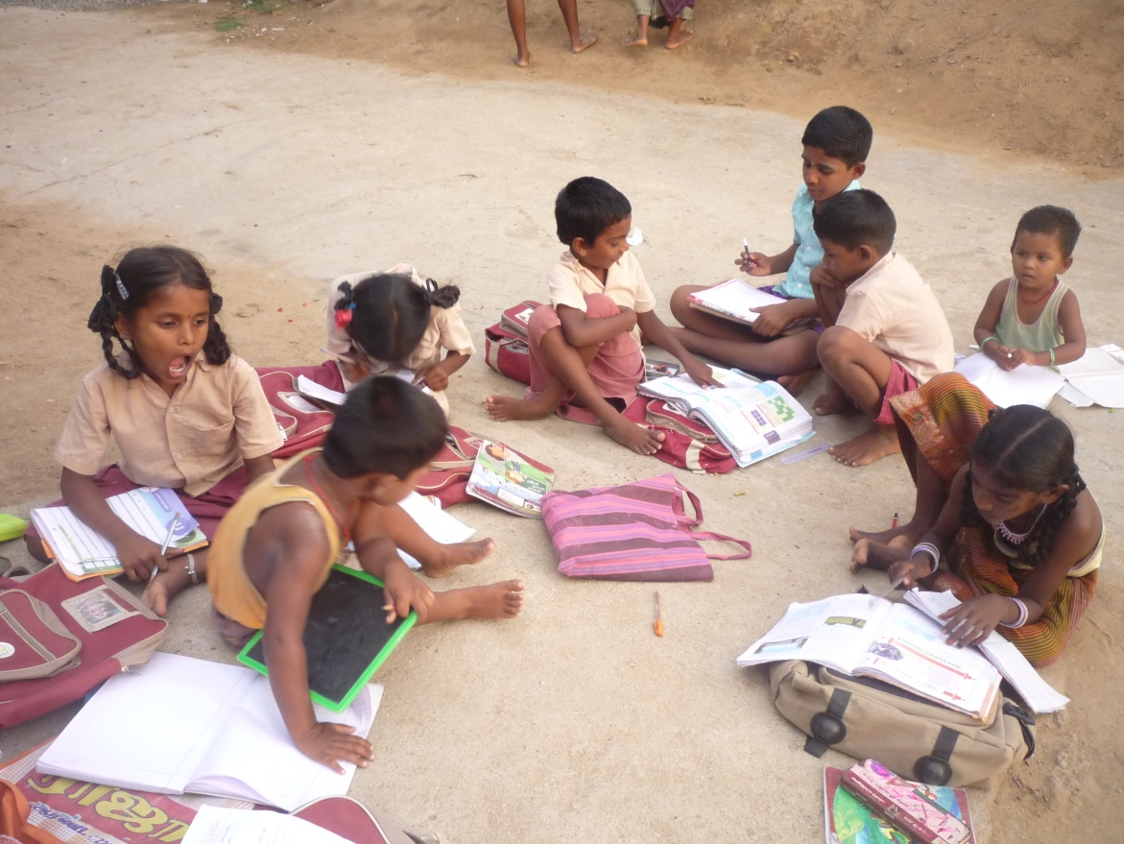

ST.XAVIER’S EDUCATIONAL DEVELOPMENT SOCIETY. (SXEDS)
INDIRANAGAR – SUSAINAGAR POST.ARNI TALUK TIRUVANNAMALAI DIST.TAMIL NADU- INDIA. PIN CODE-632326.
Land line: 04173 225577. Mobile No: 9976857419/9442557720
Email ID: xavierngo12@gmail.com / xavierngo1991@yahoo.com
Website:www.xavierngo.yolasite.com

ANNUAL REPORT 2014-15

CONTENTS

S.NO | PARTICULARS | PAGE
1. | PROFILE OF SXEDS NGO
2. | Welfare of Differently abled & vulnerable – PVP
3. | Poverty Reduction – TNSRLM Project.
4. | Women Empowerment - NABFINS
5. | TUBERCULOSIS CONTROL PROGRAM – AXSHYA
6. | PILLAR CHILDREN PROGRAM
7. | CONSUMER AWARENESS PROGRAM
8. | SPECIAL EVENTS

- PROFILE OF SXEDS NGO

SXEDS is a non-profit voluntary organization which is secular in nature. It is also a registered Society working for the holistic welfare of rural mass, in particular for women; children; mother & child and differently abled community in West Arni Block, at Tiruvannamalai District-Tamil Nadu. The organization works towards health promotion, economic and cultural growth of the vulnerable communities. It is registered under Tamil Nadu Society’s Registration Act-1975 in Cheyyar.
MOTTO: “Education that liberates you.”
Vision:
People with disabilities (socio, economic and physical Disability), women and children in the society have equal opportunity leading to improve quality of life and fully participate in a society that respects their human dignity.
Mission:
Educate, rehabilitate and equip the abilities of rural women, Children and person with disabilities, the community for initiating and facilitating the holistic development including health.
Objectives:
- To work for community development and welfare of the economically and socially backward.
- To create awareness among the downtrodden to bring about transformation in the existing structure.
- To promote leadership training to the rural youth and to promote women’s liberation.
- To organize manpower resources in villages and other places and to employ them for community development.
- To provide education to rural youth.
- To provide rural entrepreneurship to rural community.
- To promote rural development this includes empowerment of women, disabled community, agricultural laborers, landless laborers and those who residing in rural areas.
- To promote the health status of the poor and under privileged community.

02. Welfare and Rehabilitation activities of Pudhu Vazhvu Project at Polur:

Past one decade Government of Tamil Nadu with financial support of World bank, working for disabled community and vulnerable in the society. We proud to say that we are the partner NGO to cooperate and collaborate with Government machineries to reduce the poverty and economic development for the above service users in POLUR BLOCK. The following table shows our activities in our project area.
S.  No | Cluster | ID Card | Vulnerable | MG | PHP | OAP | MGNRGS | IAY | Skill | Education | IHHL
1. | Kelur | 653 | 169 | 39 | 155 | 293 | 633 | 103 | 137 | 14 | 248
2. | Polur | 573 | 172 | 62 | 204 | 142 | 390 | 76 | 34 | 22 | 225
3. | Padavedu | 653 | 184 | 32 | 222 | 400 | 606 | 39 | 25 | 18 | 144
 | Total | 1879 | 525 | 133 | 581 | 835 | 1629 | 218 | 196 | 54 | 617

02.1. Home based care for Differently abled children:

In this reporting year, along with regular rehabilitation measures, PVP district administration determined to concentrate more on home based care for differently abled children. CDFs, SGFs and BDFA fully involved with Physiotherapist Mr.C.Sridharan.B.P.T., to do successful in providing physio exercise at their home with their parents of differently abled child which is more useful for the children and the parents who take care better way. The following Case study will show our effort.

03. Poverty Reduction Program – TNSRLM – ARNI BLOCK:

To reduce the poverty and to raise economic growth among differently abled community and vulnerable section in the society Tamil Nadu Government & Government of India – New Delhi jointly implementing TNSRLM program at district level. End of previous reporting year, we conducted need assessment camp at each panchayat with team of experts. In this reporting year, we concentrate on fulfilling the need of the above service users. The following table will show the fulfillment of their needs.
District | Total no | Petty shop | Tailoring shop | Fish net weaving | Laundry | Flower selling | Goat rearing | Cow rearing | Agriculture | Others | Amount | Repayment
Agrapalayam
Differently abled | 106 | 1 | 1 | 0 | 0 | 1 | 38 | 59 | 2 | 3
Vulnerable | 70 | 2 | 2 | 0 | 1 | 0 | 25 | 40 | 0 | 1
Total | 176 | 3 | 3 | 0 | 1 | 1 | 63 | 99 | 2 | 4 | 740000 | 526000
S.V.Nagaram
Differently abled | 116 | 7 | 2 | 1 | 0 | 0 | 13 | 48 | 12 | 22
Vulnerable | 80 | 3 | 2 | 1 | 0 | 0 | 10 | 31 | 0 | 8
Total | 196 | 10 | 4 | 2 | 0 | 0 | 23 | 79 | 12 | 30 | 862000 | 602000
IRUMBEDU
Differently abled | 106 | 8 | 3 | 0 | 0 | 0 | 36 | 52 | 0 | 4
Vulnerable | 72 | 5 | 5 | 0 | 0 | 0 | 26 | 26 | 0 | 7
Total | 178 | 13 | 8 | 0 | 0 | 0 | 62 | 78 | 0 | 11 | 700000 | 535000
Chitheri
Differently abled | 144 | 10 | 6 | 0 | 0 | 0 | 34 | 50 | 4 | 34
Vulnerable | 77 | 5 | 4 | 0 | 0 | 0 | 23 | 25 | 3 | 14
Total | 221 | 15 | 10 | 0 | 0 | 0 | 57 | 75 | 7 | 48 | 962000 | 592000

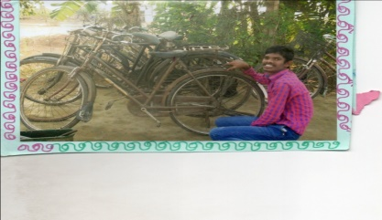

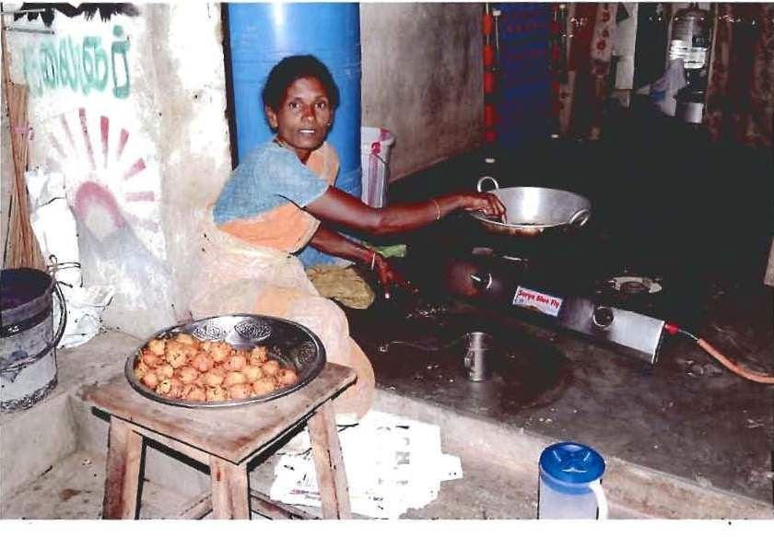

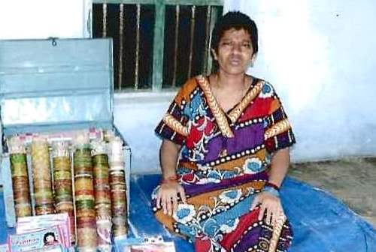

04. Women Development through NABFINS program:
To improve the women status in the society, NABFINS – BANGALORE provides credit linkage for women groups. From 2014 June onwards, we are providing loans for women groups. As on today, more than 240 groups linked with NABFINS program and more than three crore of rupees distributed to SHGs and repayment is 99%. We provided financial assistance for various purposes such as petty shops, goat rearing, agriculture purpose, education for their children, house repair, emergency (medical assistance) etc.

05. Health Program – Tuberculosis reduction – REACH TRUST:

To stop TB and save TB patients, Government of India, Government of Tamil Nadu & NGOs has taken joint venture in this field. Along with REACH TRUST Chennai, we implement TB control program in Arni area. We do awareness program on TB by GK and IOA in the rural villages.
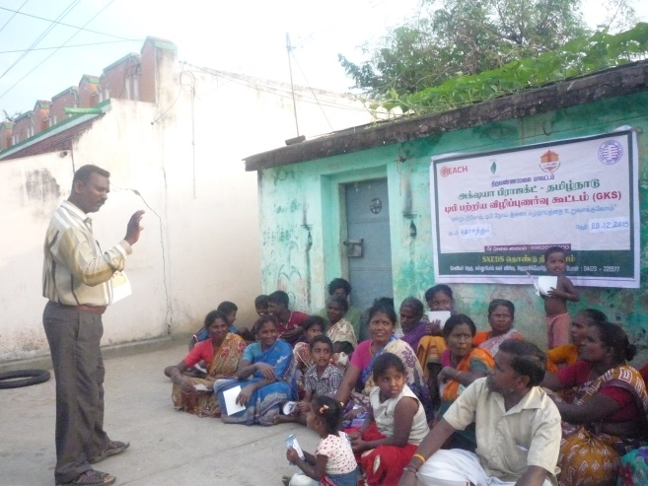

l .No | Name of the Village | Activity Name | Participated | No of referral | sputum | Findings
1 | Nethapakkam | IOA & GKS | Families - 160 | 17 | 03 | Negative
2 | Ladapadi | IOA & GKS | Families - 160 | 17 | 08 | Negative
3 | Ariyalam | IOA & GKS | Families - 300 | 25 | 10 | Negative
4 | Chitheri | IOA & GKS | Families - 310 | 32 | 10 | Negative
5 | Irumpedu | IOA & GKS | Families - 315 | 38 | 12 | 1 positive
6 | Poosimalaikuppam | IOA & GKS | Families - 400 | 55 | 05 | Negative
7 | Mullipet | IOA &GKS | Families - 310 | 34 | 16 | Negative
8 | Kaikilaithangal | IOA &GKS | Families - 315 | 28 | 14 | Negative
9 | Kalpoondi | GKS | Families - 016 | 06 | 00 | Negative
10 | Ambetkar Nagar | IOA | Families - 300 | 24 | 15 | Negative
11 | Vilai | GKS | Families - 015 | 06 | 04 | Negative
12 | Mattathari | IOA & GKS | Families - 318 | 35 | 15 | Negative
13 | katteri | GKS | Families - 015 | 05 | 03 | Negative
14 | Sangeethavadi & Paiyur | Both of GKS | Families - 025 | 12 | 06 | Negative
 |  | Total | 2969 | 334 | 121 | 1 positive

06. PILLAR CHIDLREN PROGRAM:

To motivate, to provide proper guidance to rural school going children, our Board members decided to start new program for rural children PILLARS CHILDREN PROGRAM. Here we concentrate more on rural and vulnerable children. Dalit and arunthathiar community are vulnerable in the community. In this reporting year, we selected two evening study centers – Sirumur – Arunthathiar colony and 12 Puthur – dalit community and both downtrodden and vulnerable in the society. We have appointed teachers a well-qualified to supervise centers. Once in a month we review their activities.
On Independence Day we conducted various competition and distributed prizes for the winners. On Pongel day we conducted sports for the children and quiz program, group activities for them. Due to financial constraints, we could not extent new study center. By our sincere effort children from centers scored good marks in their public exams.

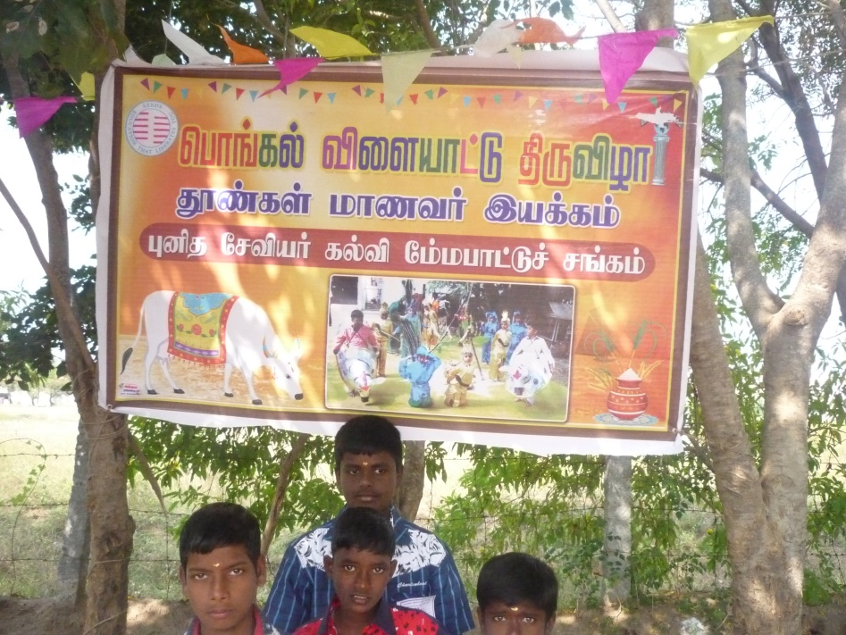

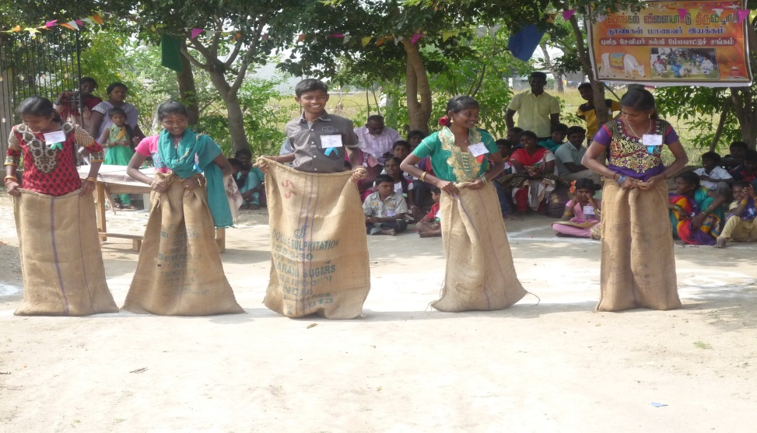

07. Consumer Awareness for School going children program:

To make our children responsible citizens, we conducted three consumer awareness programs for school going children. Miss.Anita Xavi.B.A.B.L. Advocate – Chennai High Court shared with children about consumer protection and other legal formalities. Participant Miss.Lawanya is sharing to other children what she understood in the class.
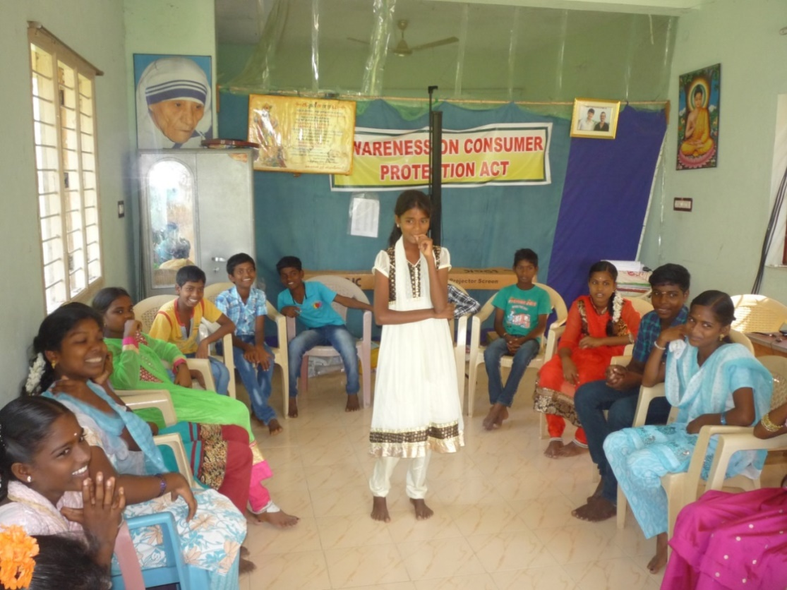

08. Dates to be remembered: 2015 - ’16.

Date | Event
09.04.’15 | Child Labour Elimination – One day sharing – District Collector & UNCIEF – Chennai.
24,25.04.’15 | Climate Change – Children Program at PCTC – Kondam - Kariyandal
21.05.’15 | TNSRLM – Review by District Collector – Tiruvannamalai.
05.06.’15 | Mr.Sridharan – PVP – Physio activities - Assessment – PVP project.
23.06.’15 | TB Review at District Level – Tiruvannamalai.
04.07.’15 | Monthly review for staffs – SXEDS.
11.07.’15 | PILLAR CHIDREN PROGRAM – Sirumur & 12 Puthur – inauguration of two study centers.
31.07.’15 | TNSRLM Review meeting – Tiruvannamalai.
15.08.’15 | Independence Day Cultural Program by Children from study centers.
04.09.’15 | TNSRLM Review Tiruvannamalai.
09.09.’15 | TB Review meeting - Triuvannamalai.
12,13.09.’15 | TNVHA State level Network – General Body meeting- POLUR
23.09.’15 | DPCC meeting Collector office Tiruvannamalai.
14,15,16.09.’15 | TNCP Net Work – Mudumalai – Environment issue training.
22,23.12.’15 | Refresh Training for CDFs – TNSRLM.
29.12.’15 | DPCC meeting – Collector office – Tiruvannamalai.
07.01.2016 | National Trust – New Delhi – SPASTIN – Chennai one day session on Revised scheme.
09.01.’16 | FCRA Training – TNVHA Chennai.
17.01.’16 | Pongel Day Celebration – Children from PILLARS
01.02.’16 | TB Review Tiruvannamalai.
24.02.’16 | PVP Review State level Chennai.

Acknowledgements:

We gratefully acknowledge the contributions of many in the growth of SXEDS NGO.
Our grateful thanks to all our friends and well-wishers for their continuing support.

Executive Board Members.
Annikka family & friends – Germany.
Tom, Flo parents & Friends – Germany.
Pudhu Vazzhvu Project – Triuvannamalai.
Tamil Nadu State Rural Livelihood Mission – Tiruvannamalai.
NABFINS – Bangalore.
REACH TRUST – Chennai.
Prof.Rev.Fr.Roy Lazar.P.Hd. Chennai University.
Rev.Fr.Ramesh – Germany.

